1. **Experiment:** Flow Cytometric Analysis of NK Cell Activity under acidic condition
2. **Time:** 2025.09.10-2025.09.20
3. **Member:** Xudong Tang, Yang Jin, Binxuan Zhang, Kaiqing Zhang, Xuantong Liu
4. **Principle:**

This experiment uses flow cytometry for multi-parameter cell analysis to explore how acidic conditions affect NK cell activity. NK cells are identified via CD56-PEas CD3⁻CD56⁺ populations. CD107serves as an activation marker: surface expression indicates cytotoxicity (CD56⁺CD107a⁺ = active NK cells). Flow cytometry excludes doublets/dead cells, then quantifies the ratio of active NK cells to total NK cells to assess functional impacts.

1. **Materials:** Flow cytometer, CD107a-APC, CD56-PE, Ice-cold PBS Staining buffer, Brefeldin A, 4% paraformaldehyde (PFA), 0.1% Triton X-100, 15 mM lactic acid, K562 cell line
2. **Method:**
3. Cell preparation:

Our mimics (B51G35R-G, B51G35R, B34G35R-G, B34G35R, B51G9-G, B51G9) were previously added and proliferated to NK cells co cultured with K562 cell line, incubated under acidic condition of 15 mM lactic acid (pH 6.4), and neutral pH of 7.4 respectively. The cells are resuspended in pre-warmed (37 ℃) culture medium at appropriate density.

1. Surface staining:
2. CD107a expression was analyzed in all twenty groups demonstrating cytotoxic activity using flow cytometry.
3. Post-cytotoxicity assay, cells in each well were washed once with 1 mL of ice-cold PBS and resuspended in 100 μL staining buffer.
4. Cells were stained with CD107a-APC (BioLegend, 328620) and CD56-PE (BioLegend, 362508) to identify NK cells.
5. Activated NK cells were defined as CD56⁺CD107a⁺, while total NK cells were CD56⁺.
6. CD107a-APC (1:100) and CD56-PE (1:50) were added. Samples were incubated at 4 ℃ for 30 min protected from light. Control tubes were prepared.
7. 200 μL ice-cold Flow Staining Buffer was added. The tube was centrifuged at 300 × g for 5 min. And the supernatant was aspirated completely.
8. The cells are resuspended with 100-200 μL Fixation Buffer, and incubated at room temperature for 15-30 min.
9. 200 μL Flow Staining Buffer was added and the tube was centrifuged at 300 × g for 5 min. The supernatant was aspirated completely.
10. Acquisition:
11. The suspension was transferred to flow cytometry sample tubes.
12. Analysis Strategy:

Gate to exclude doublets (using FSC-A vs FSC-H).

Gate to exclude dead cells (using a viability dye).

Identify the target cell population (NK cells: CD3⁻ CD56⁺).

Analyze CD107a expression level on the gated target cell population.

1. **Result:**

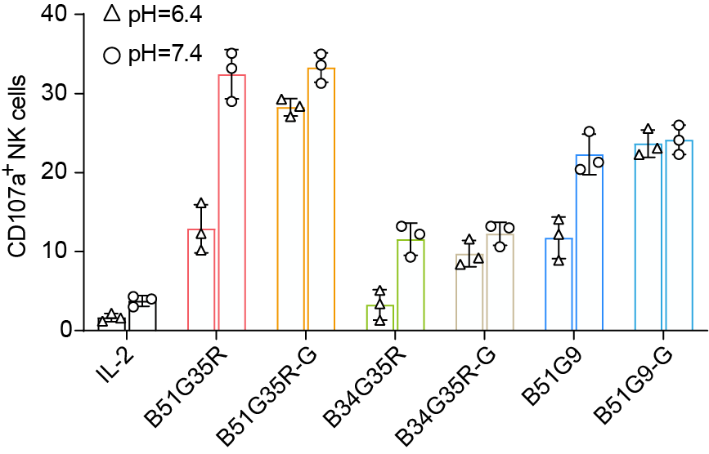

**Figure.1** CD107a+ detection of NK cells pre-activated by IL-2, B51G35R, B51G35R-G, B34G35R, B34G35R-G, B51G9, B51G9-G separately at both pH=6.4 and pH=7.4. Data are representative of at least three independent experiments (\*\**P* < 0.01, \**P* < 0.05).